Table of Contents

**Assignment's Objective** **2**

**Our Course of Action** **2**

**Assignment's Quick Steps** **2**

**The Dataset** **2**

Format 3

Reading the Dataset 3

**Text Preprocessing** **4**

Data Filtering 4

Stop Words 4

Tokenization 4

Lemmatization 5

Extracting Features 5

Bag of Words 5

Sentiment Analysis 5

Word Embedding 8

**Supervised Learning** **9**

**Big Picture** **10**

Bag of Words 10

Semantic Analysis 10

Word Embedding 11

Overall Results 11

**Python Libraries** **12**

# Assignment's Objective

Main objective of this assignment is to classify a tweet as **Ironic** or **Non-Ironic**. This Assignment covers **natural language processing** and **classification**.

# Our Course of Action

In general, irony is a tricky subject that even humans sometimes fail to detect it in a conversation or a sentence, but still, it must have a certain pattern or there exist some words that hints that irony exists. We examined many sentences that contain irony, and we deduced the following.

1. A negation word, like **not** and **no,** exists in the sentence.
2. The sentence usually contains two emotions that contradict each other.  
   We decided to split the sentence on the **conjunction** of the sentence, if it exists, and evaluate the emotion of each of each part of the sentence.  
   Examples of **conjunctions** are which, and, but,..etc.
3. The sentence usually has a negative sentiment feeling.

# Assignment's Quick Steps

1. Text Preprocessing
2. Train Models
3. Results

# The Dataset

The used dataset in this assignment is provided the one provided in SemEval-2018 task 3. It consists of **3842** tweets as a **total**. The tweets were picked by searching Twitter for tweets that contains hashtags **#irony**, **#sarcasm** and **#not**. Later, the tweets were refined by three students in linguistics and second-language speakers of English.

### Format

The dataset consists of **3842** tweets as a **total**.

* **604** tweets are classified **as Non-Ironic**.
* **2396** tweets are classified as **Ironic**.

There are 3 attributes, separated by **1 tab**, that are in the following order:

1. Index
2. Class (either 0 or 1)  
   1: Ironic  
   0: Non-Ironic
3. Tweet

Below is a sample of the dataset.

### 

### Reading the Dataset

According to the format above, we split the dataset into **3** vectors.

* **Index –** contains index of each tweet
* **Labels –** contains **0/1 (Ironic/Non-Ironic)** of each tweet
* **Tweets** – contains each tweet

For every line in text file of dataset, split at tabs and save each part of the tweet into correct vector.

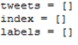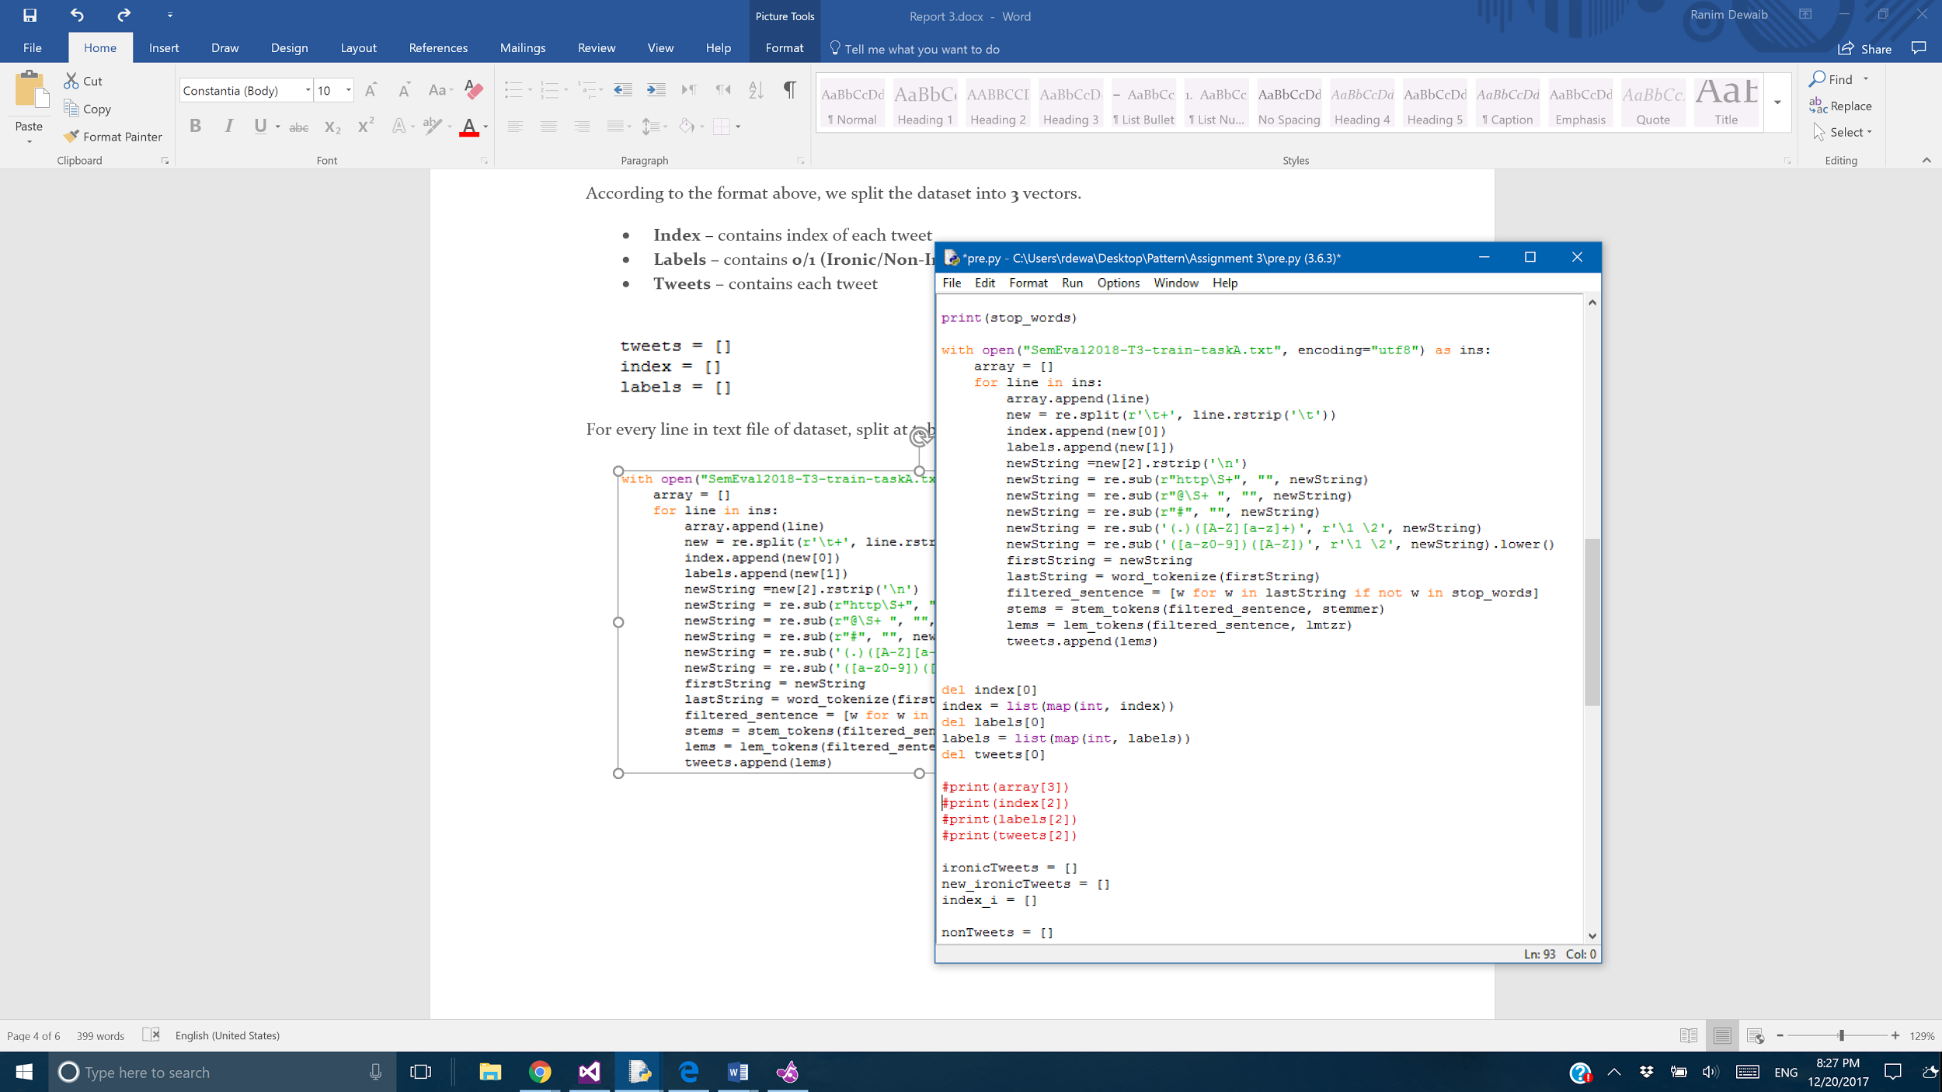

# Text Preprocessing

## Data Filtering

To generate good results and lessen the number of unneeded computations, the tweets are filtered according to certain criteria.

### Stop Words

Generally, in Natural Language Processing, the first step is to always filter the data and remove any insignificant and redundant words. There are known words, called Stop Words, that are always removed to enhance the performance.

Below is a set of some of the **Stop Words**.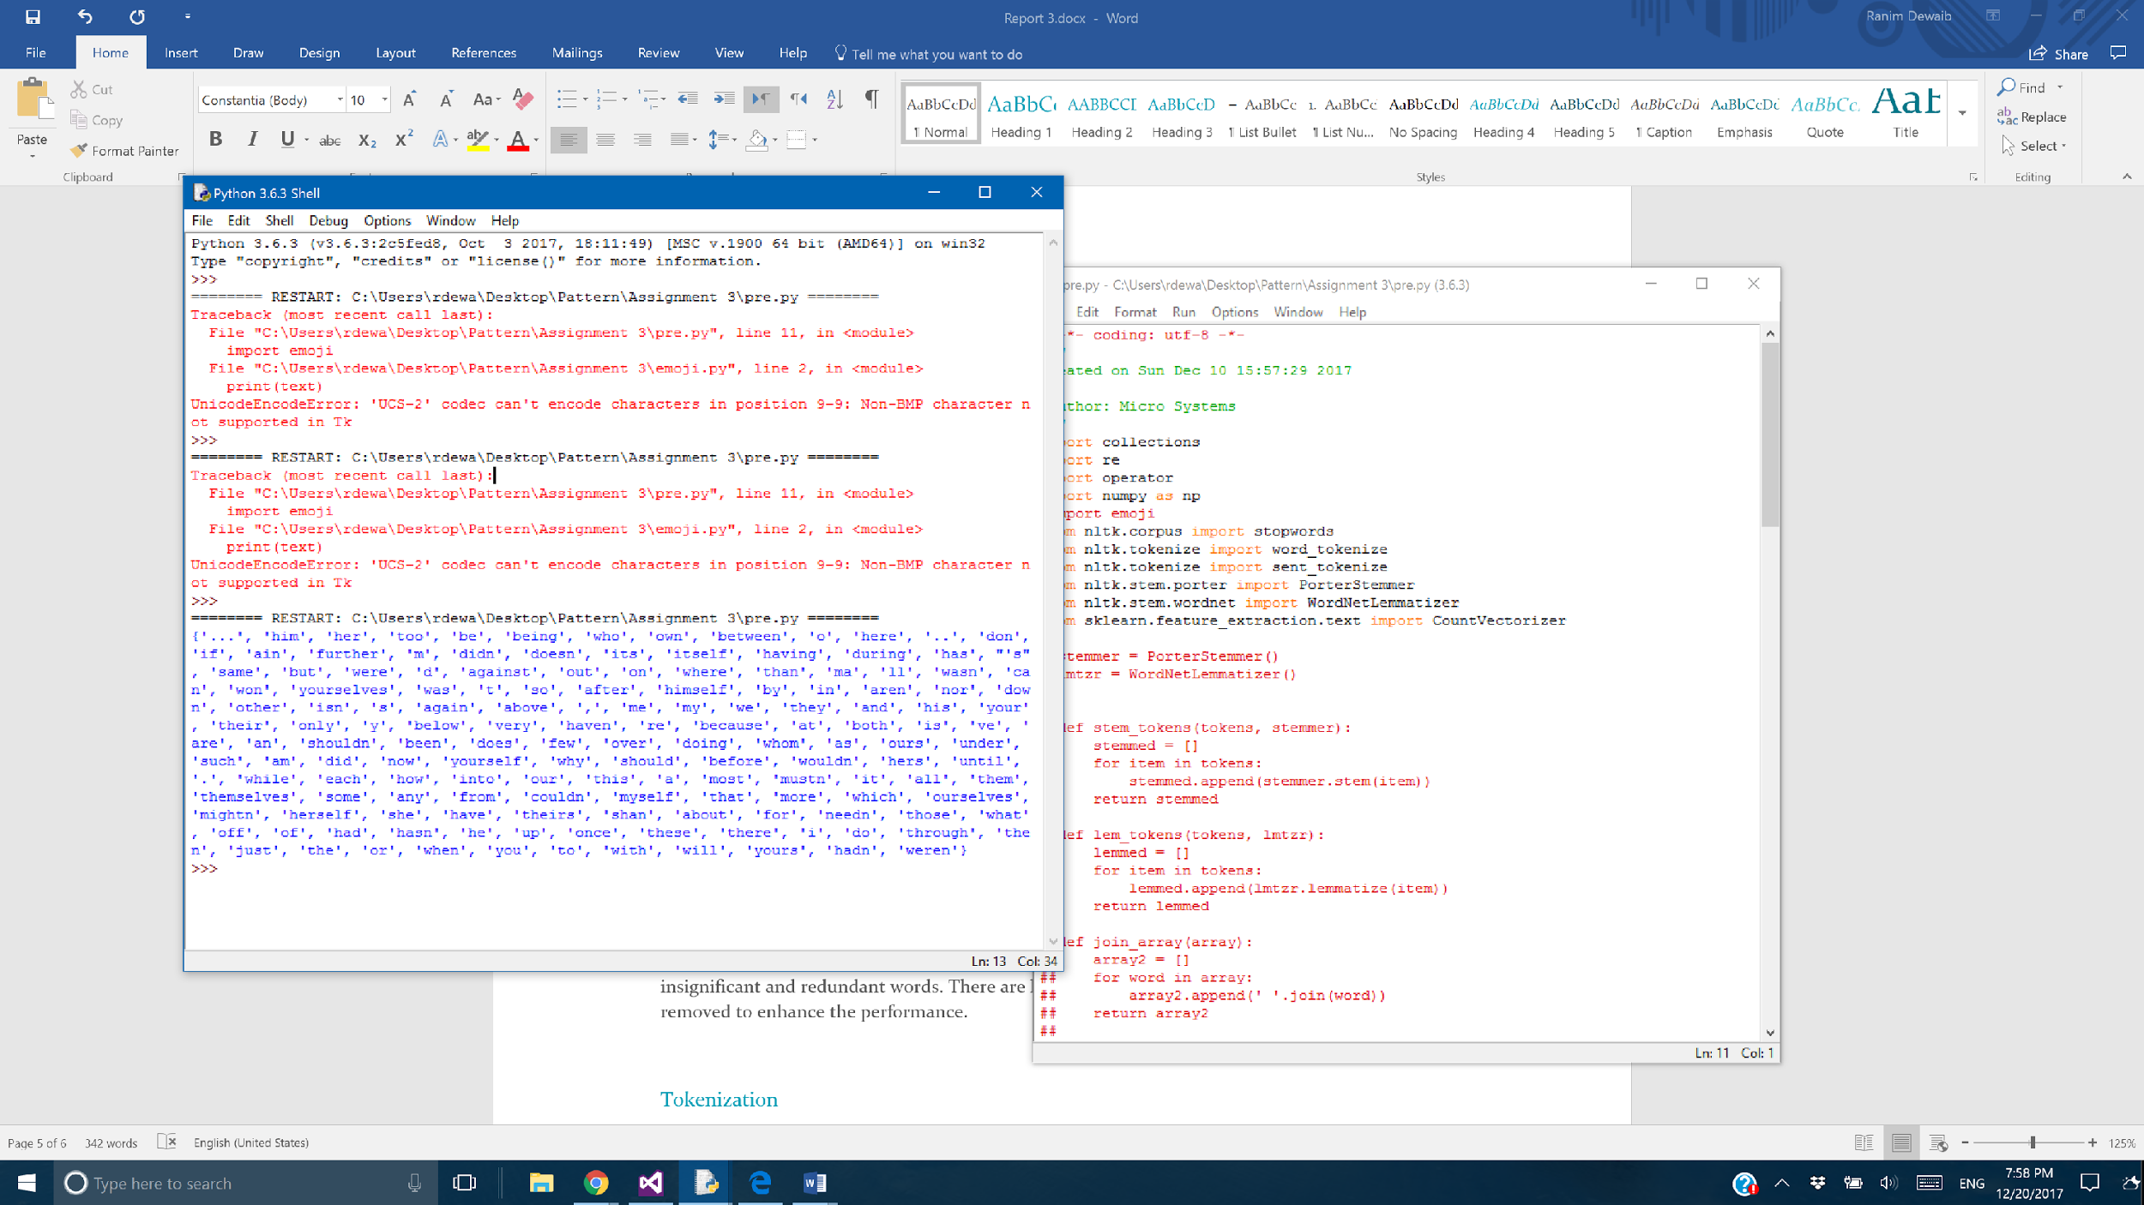

For the objective of this assignment, irony detection in tweets, we removed some words from the **Stop Words** sets because they are significant in detection the irony. We removed any negating words and conjunctions. Below is the list of words we removed the **Stop Words** set.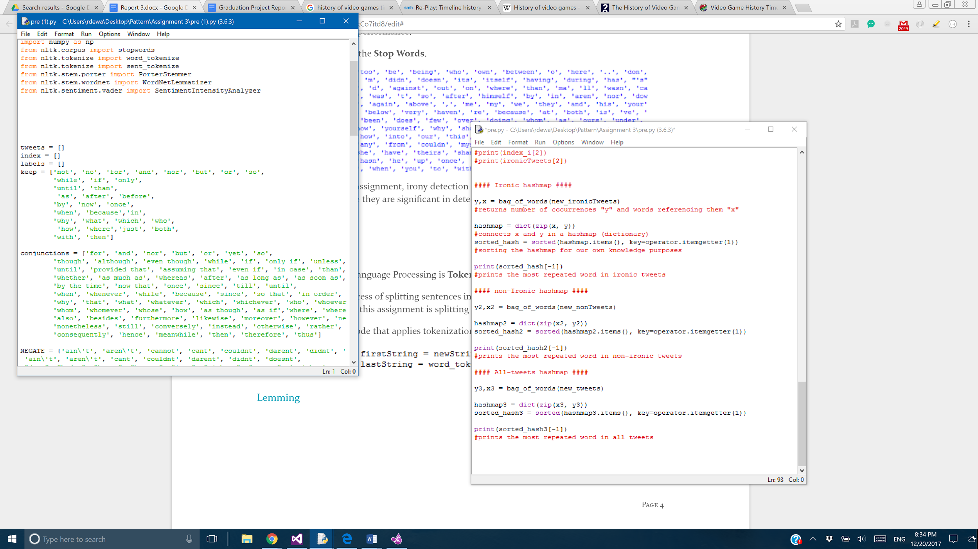

### Tokenization

Second step in Natural Language Processing is **Tokenization.**

**Tokenization** is the process of splitting sentences into single words or chunks, group of words. The **tokenization** applied in this assignment is splitting the sentence into single words.

Using nltk library, below is the snippet of code that applies tokenization on tweets.

### Lemmatization(BONUS)

**Lemmatization** is the process of getting the root of a word. **Lemmatization** takes into consideration the morphological analysis of words. A **Lemma** is the same for variations of a word, therefore; it reduces noise.

Using nltk library, below is the snippet of code that applies **Lemmatization** on filtered, tokenized tweets.

We also have sentences filtered from mentions hash tags and URL’S and numbers

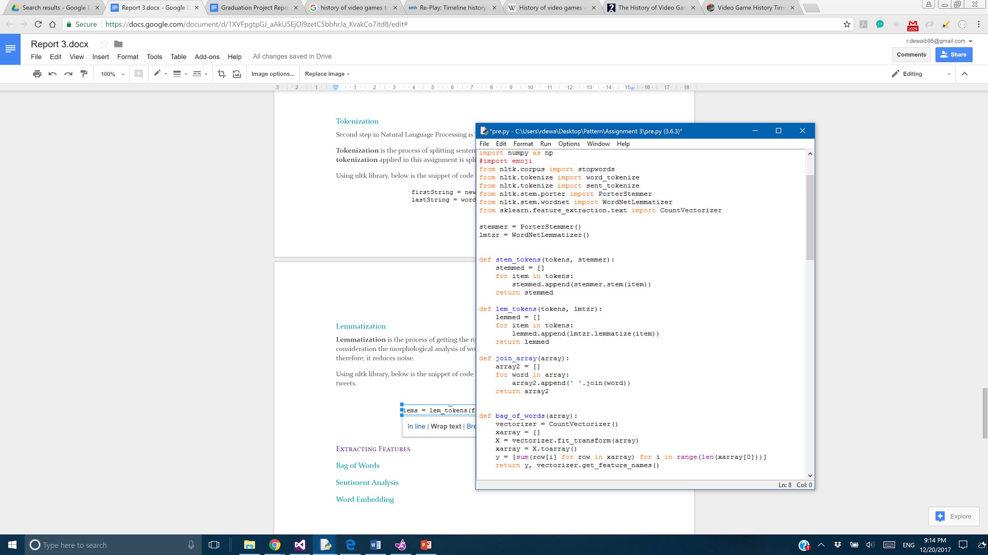



## 

## Extracting Features

### Bag of Words

First, we created 3 arrays. the first array for the words in ironic tweets, the second array for the words in non ironic tweets and the final array for words in all tweets.

Second, we calculated the number of repetitions of every word in the ironic tweets array across all ironic tweets. We repeated the same step for every word in the non ironic tweets across all non ironic tweets.

Third, we extracted the most common words (with highest frequency) across both tweets to eliminate them from our processing to the data - since they won’t be effective in determining if a tweet is ironic or not.

Fourth, we created hashmaps for the words as 'key' attribute and their frequency value as 'value' attribute - one hashmap for words in ironic tweets, another for words in non ironic and the last one for the common ones.

Fifth, we sorted the hashmaps for easy acquiring of the words with highest frequencies.

Finally, we added the hashmaps as another feature for the data processing procedure.

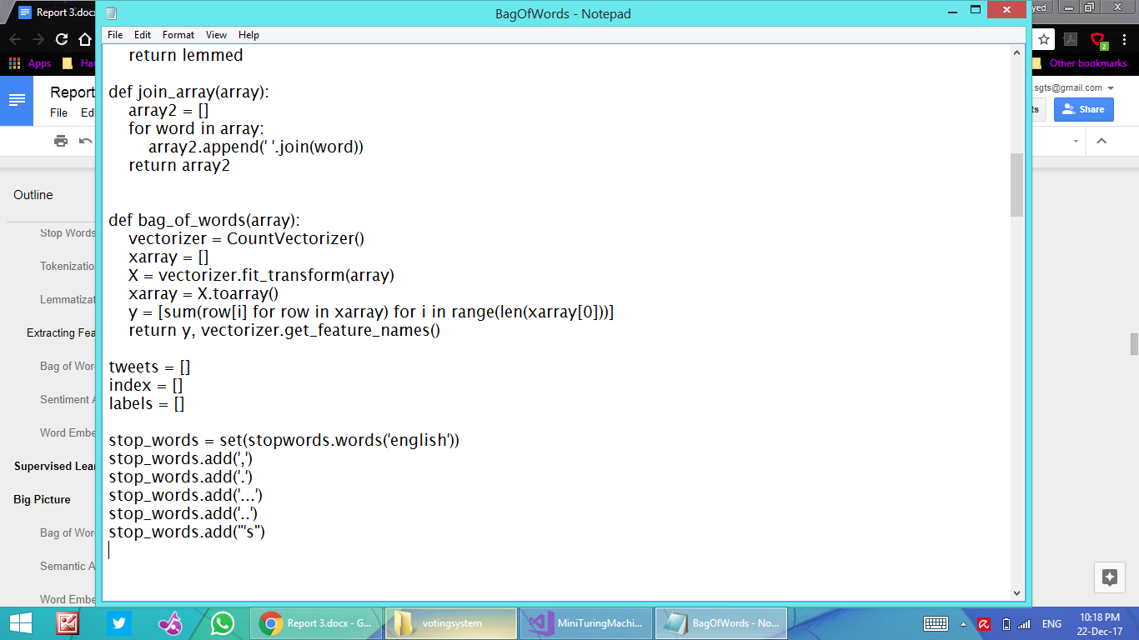

### 

### Sentiment Analysis(EXTRA FEATURE FROM OUR SEARCH)

We used sentiment analysis to help detect irony in a tweet. We used **polarity** feature of a word to determine if the feelings in the tweet changed 180 degrees. For the purpose of this assignment, we removed some of the words from the **Stop Words** set as mentioned above. We also didn’t apply **lemmatization** in this feature because it will affect the performance of the polarity test. We also handle **emojis** and **negation words** in the tweets since they contribute to the polarity of the sentence. 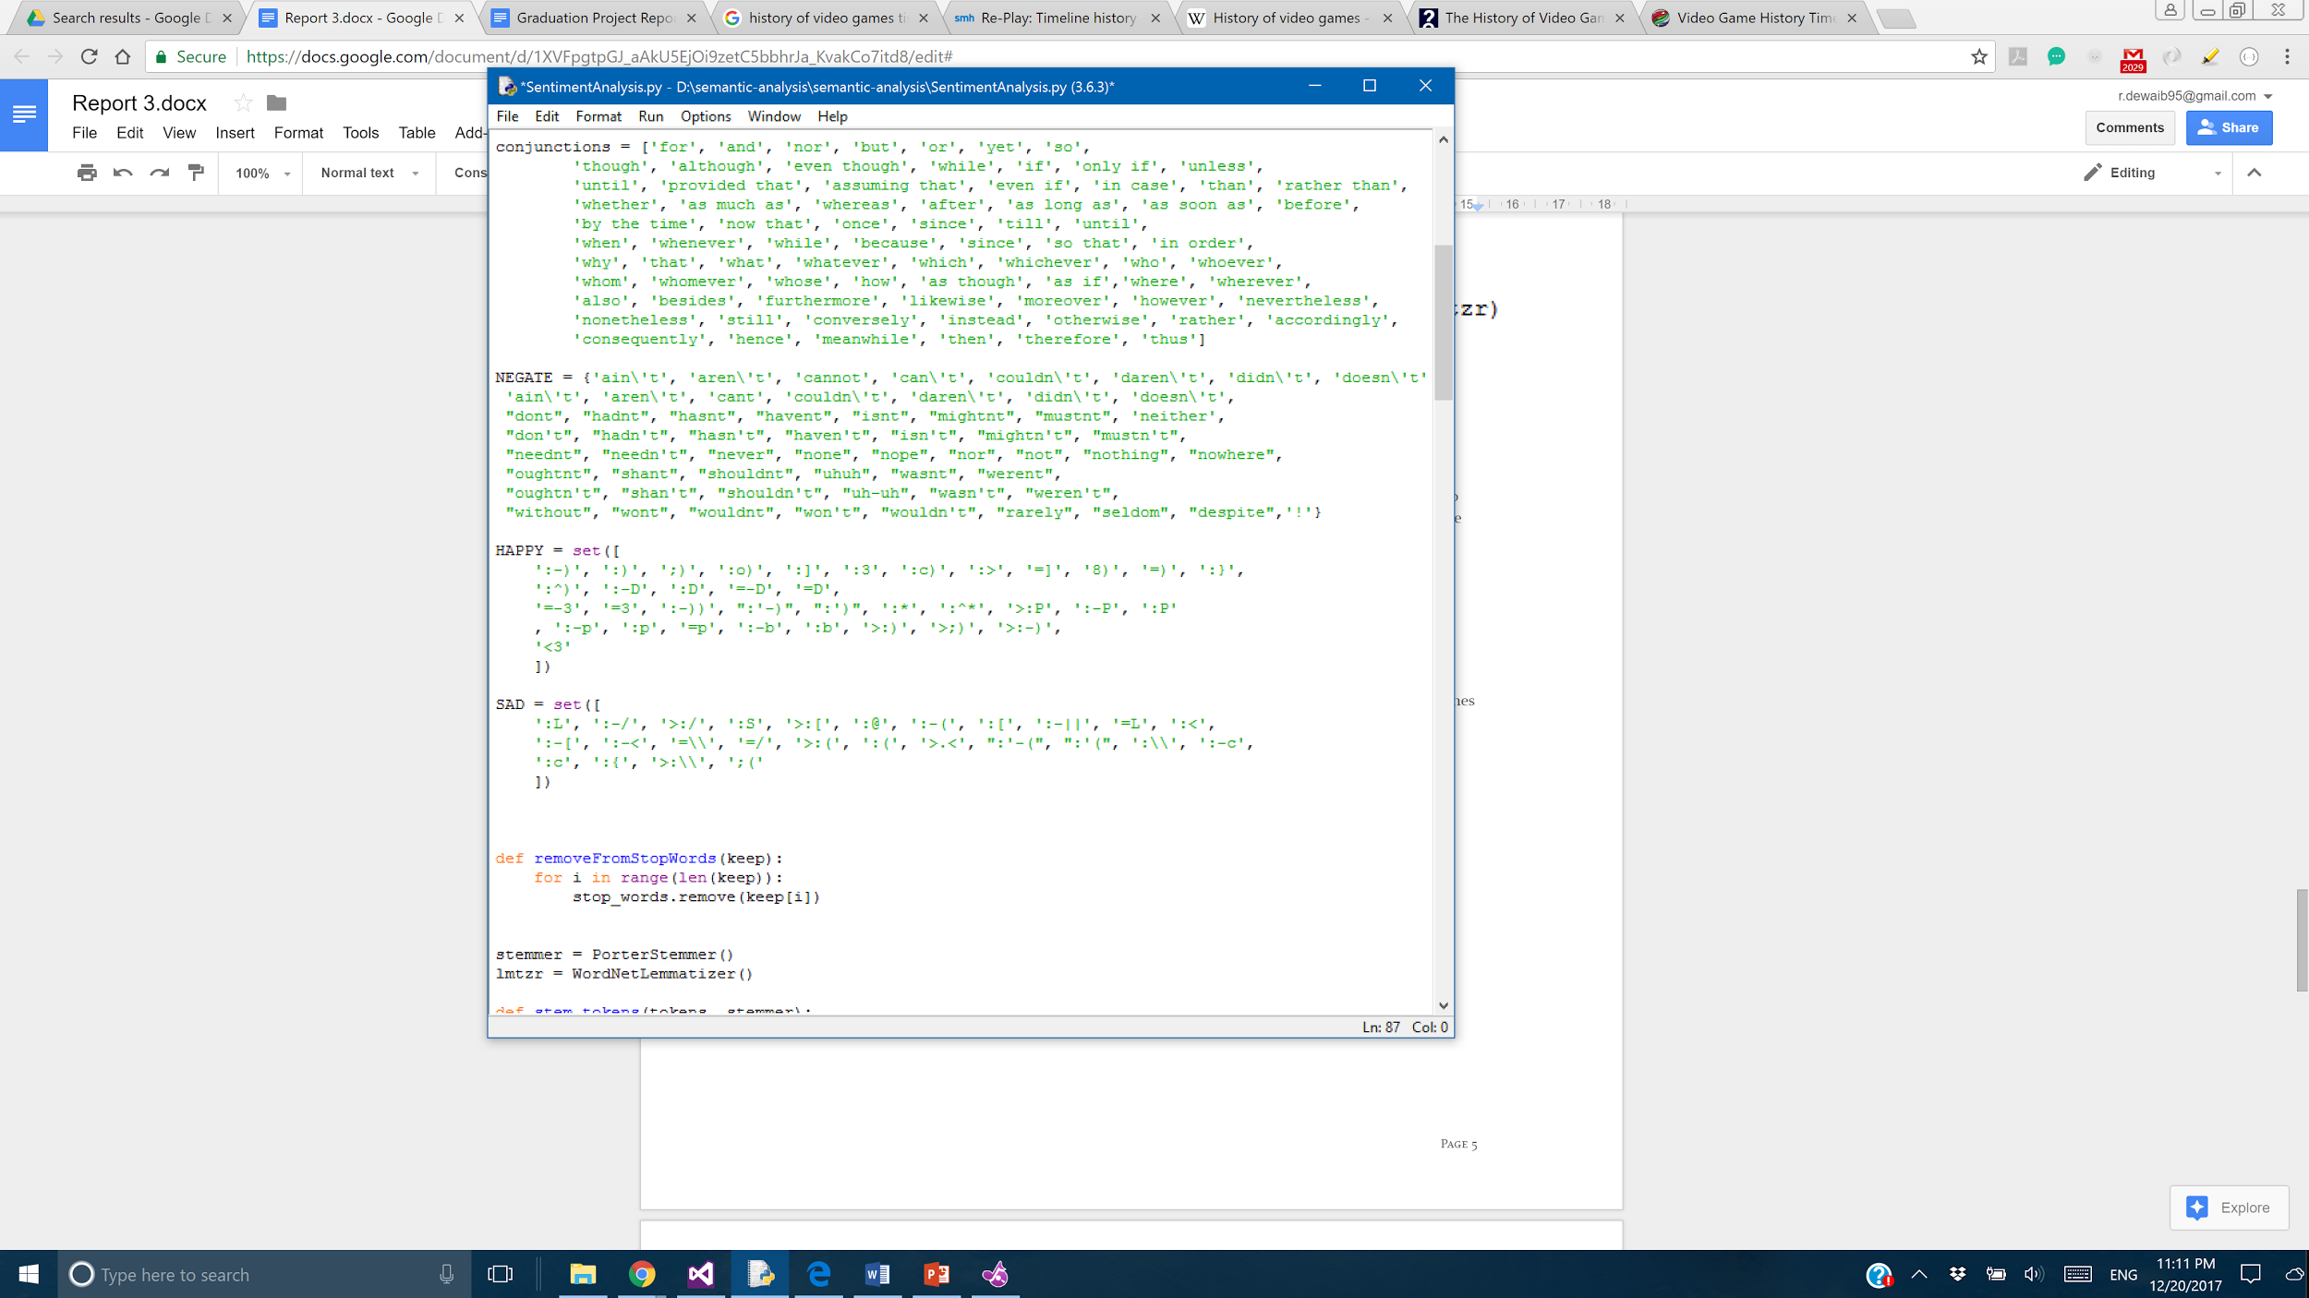

Below are the steps we perform.

1. Split, into two parts, the tweet on a conjunction from list below. We gathered all the available conjunctions in English Grammar. We handle all the conjunctions except the ones that consist of more than one word like not only...but also,..etc.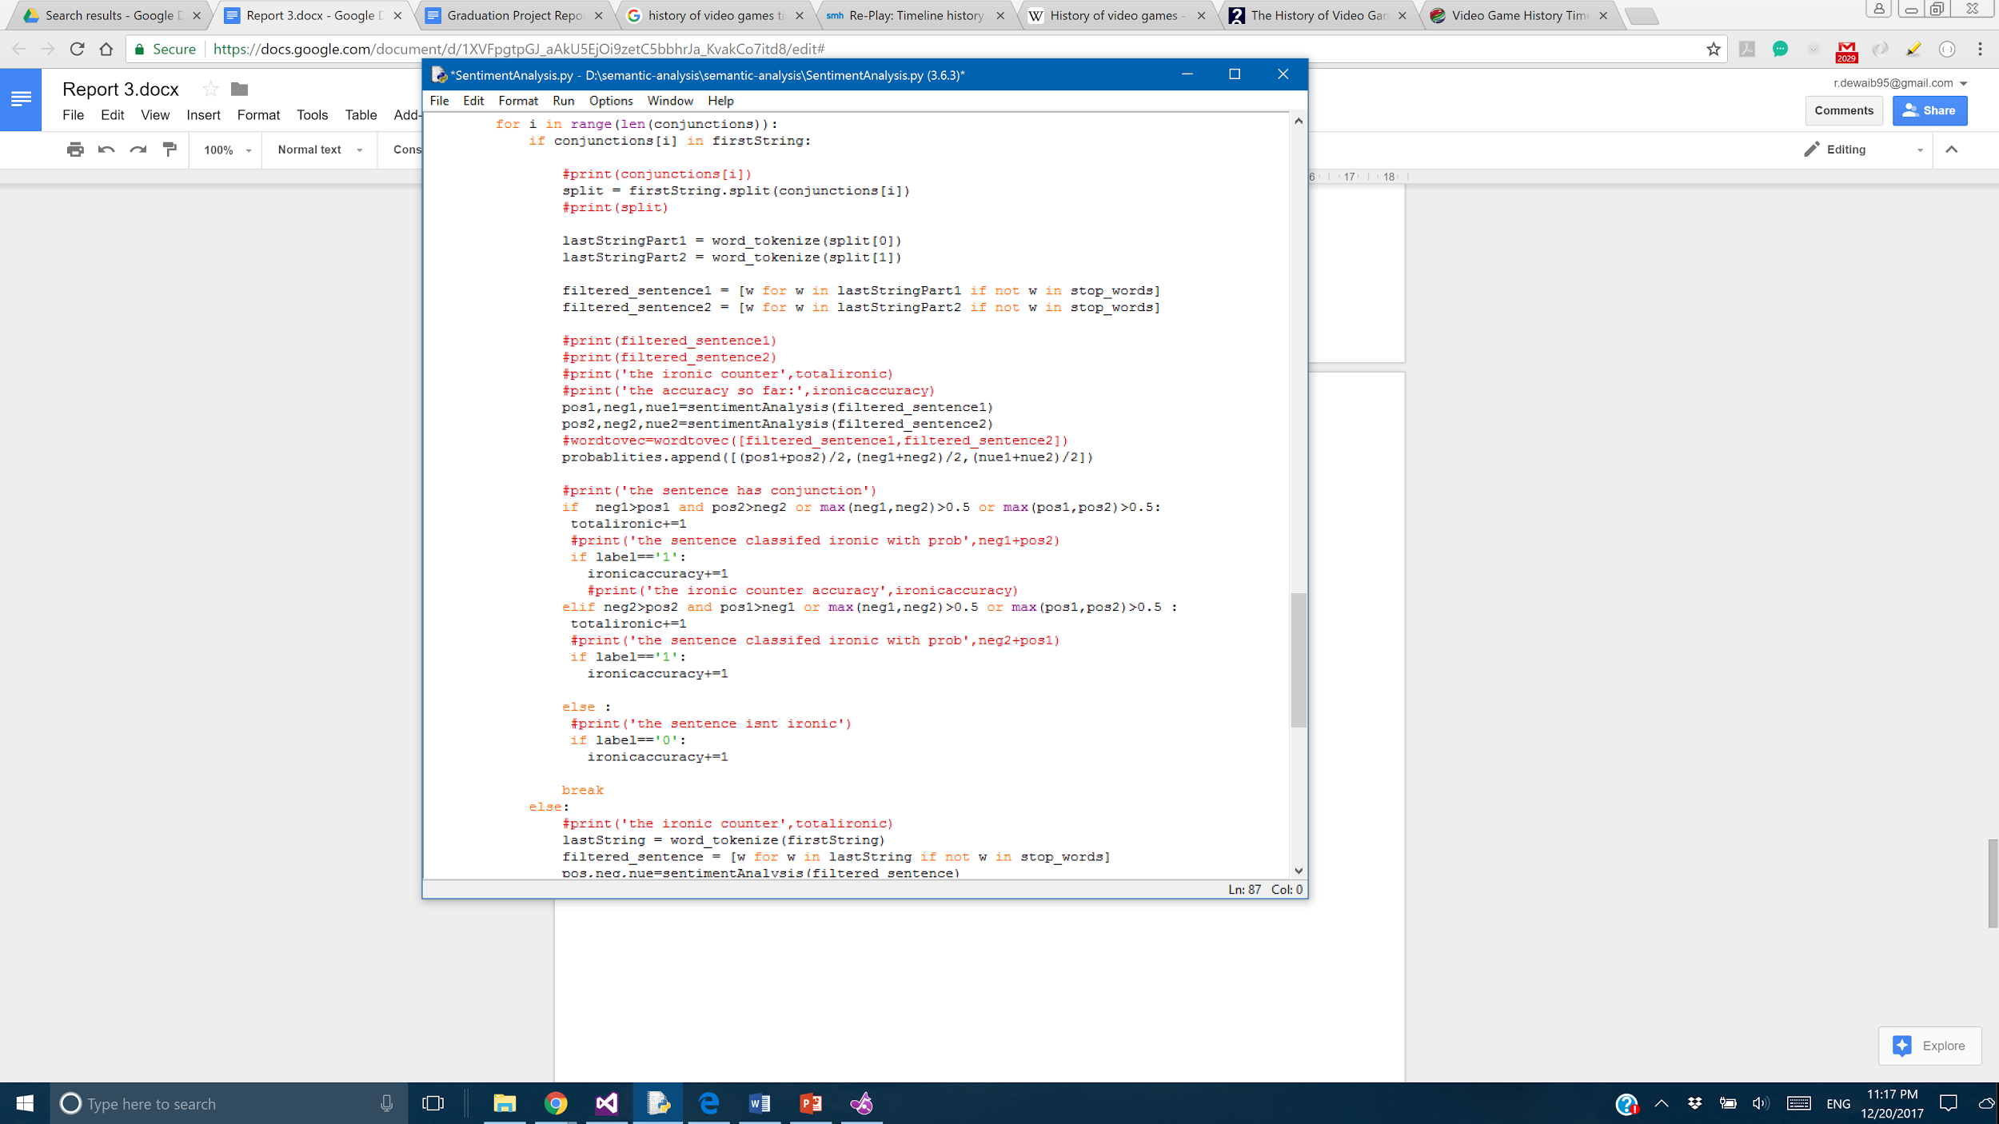
2. Tokenize each part of the tweet.
3. Remove **Stop Words** from each part of the tweet.
4. Evaluate polarity of each word of each part of the sentence.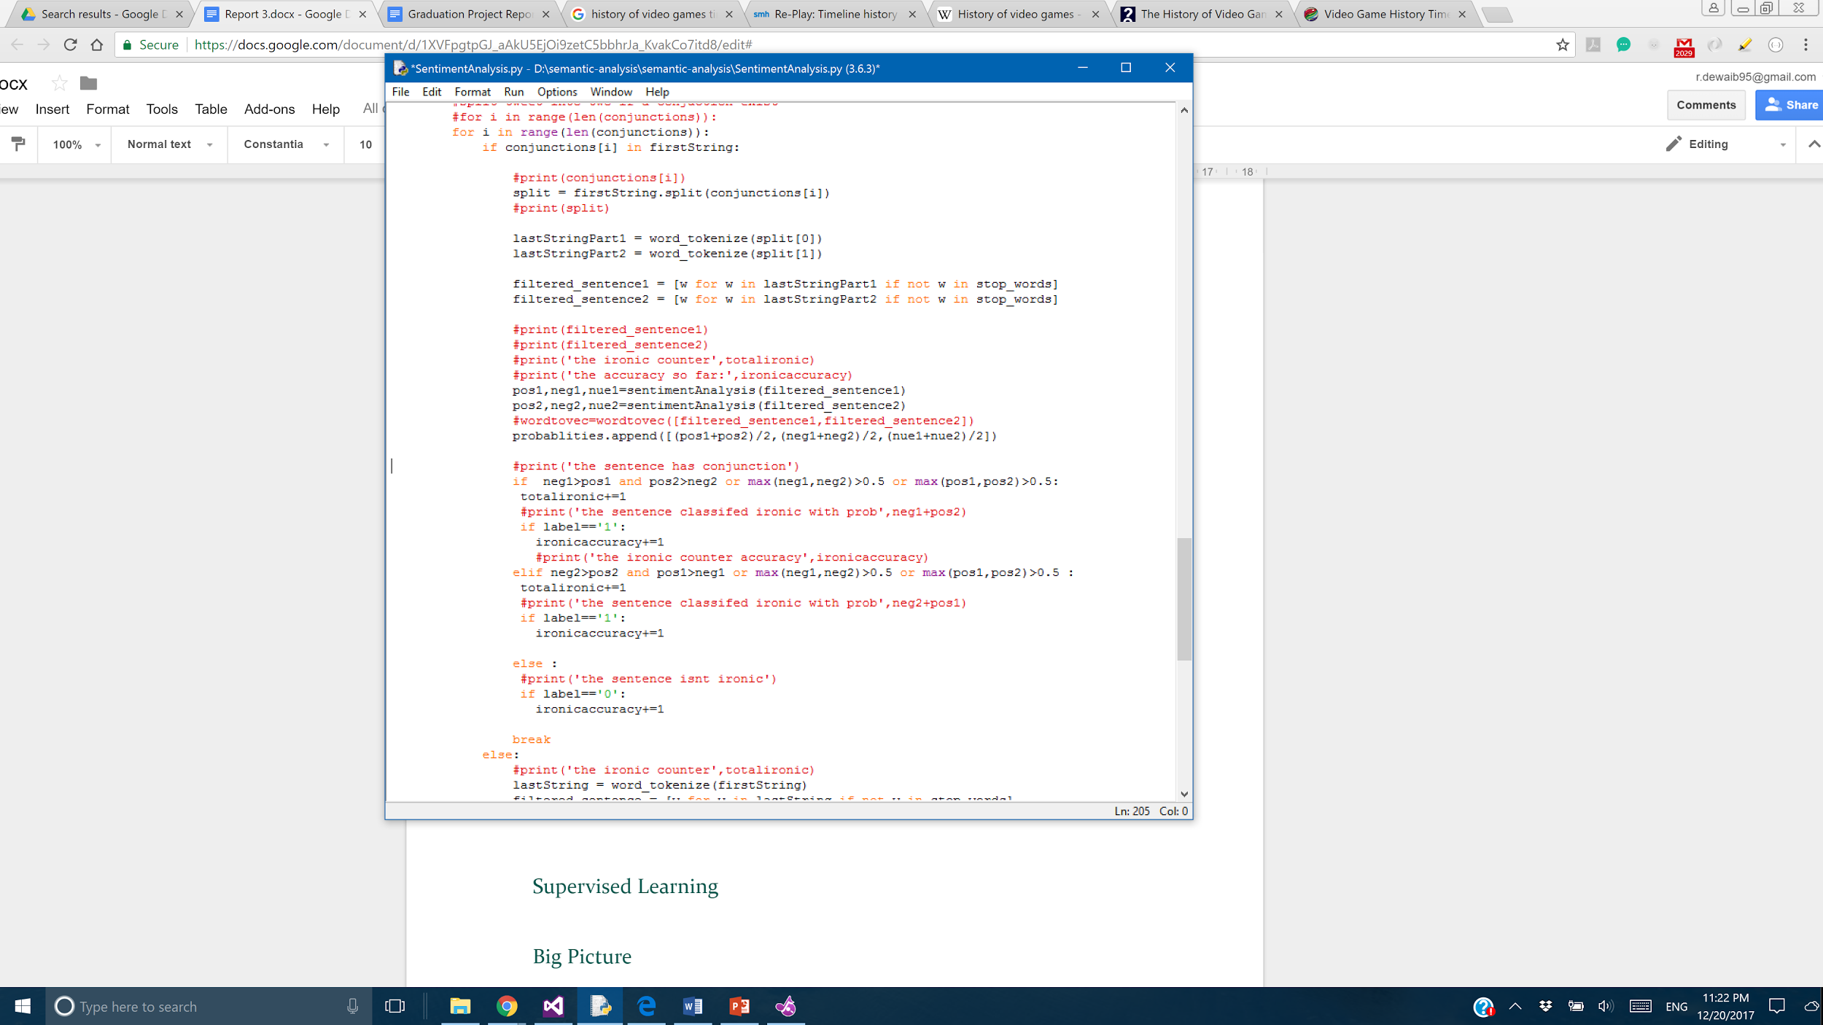

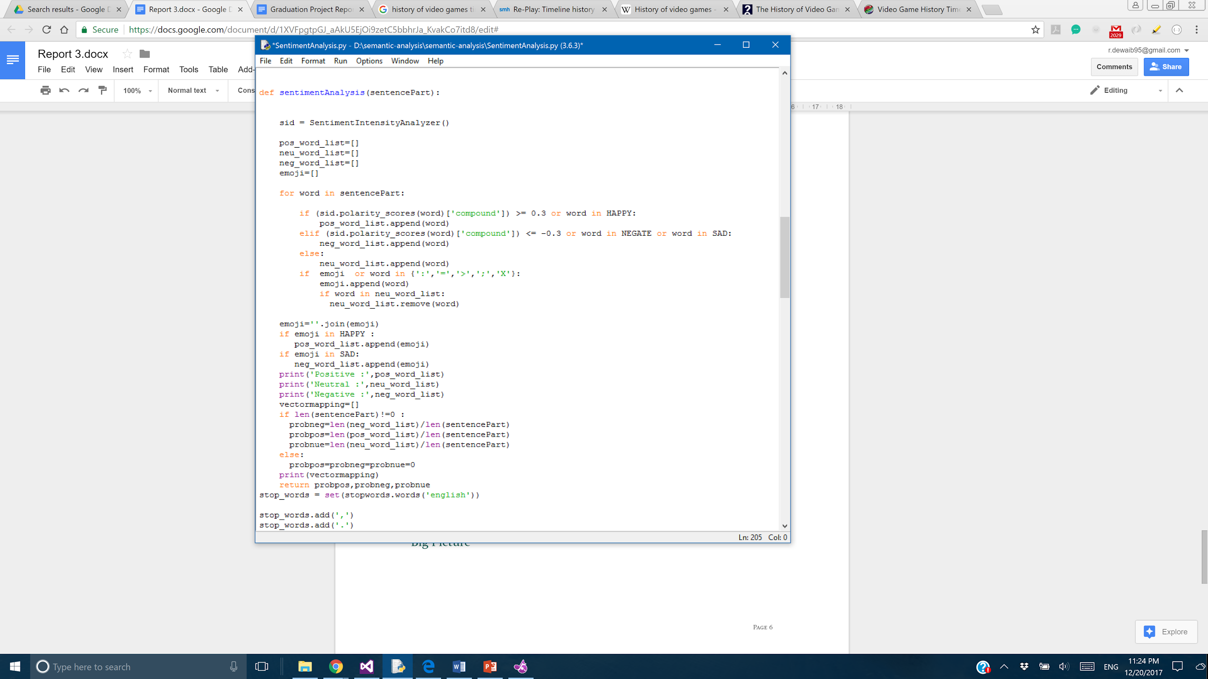

The **sentimentAnalysis** method takes part of the tweet as input, and using **SentimentIntensityAnalyzer** from **nltk** library and the sets of the emojis, the polarity of each word is returned as either positive, negative or neutral. The threshold **0.3** was tuned by running the methods with several values and picking the right value that returned each word to its appropriate polarity.

To calculate the **overall polarity** of one part of the tweet, we search for the polarity category that has **highest** number of words and return it as the **overall polarity** of this tweet. Overall, we calculate the probability of each category of the polarity and pick the **highest**.

5. Compare the polarities of the sentence parts. There are three conditions the tweet will be classified as **Ironic.**

1. Sentence contains contradicting polarity, positive and negative.
2. Total negative polarity of the whole tweet is greater than **0.5**.
3. Total positive polarity of the whole tweet is greater than **0.5**.

The value **0.5** was chosen after some testing and tuning.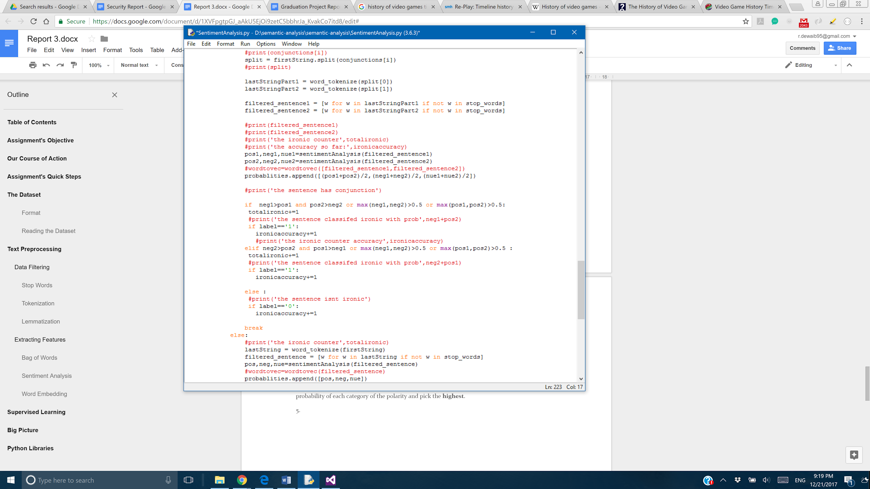

### Word Embedding(EXTRA FEATURE FROM OUR SEARCH)

First, we created a model with the training data to act like a dictionary for the coming processing. Second, we used every word in every tweet and passed it to the model - which as a result, returned an equivalent numerical vector to the word with length = 100.

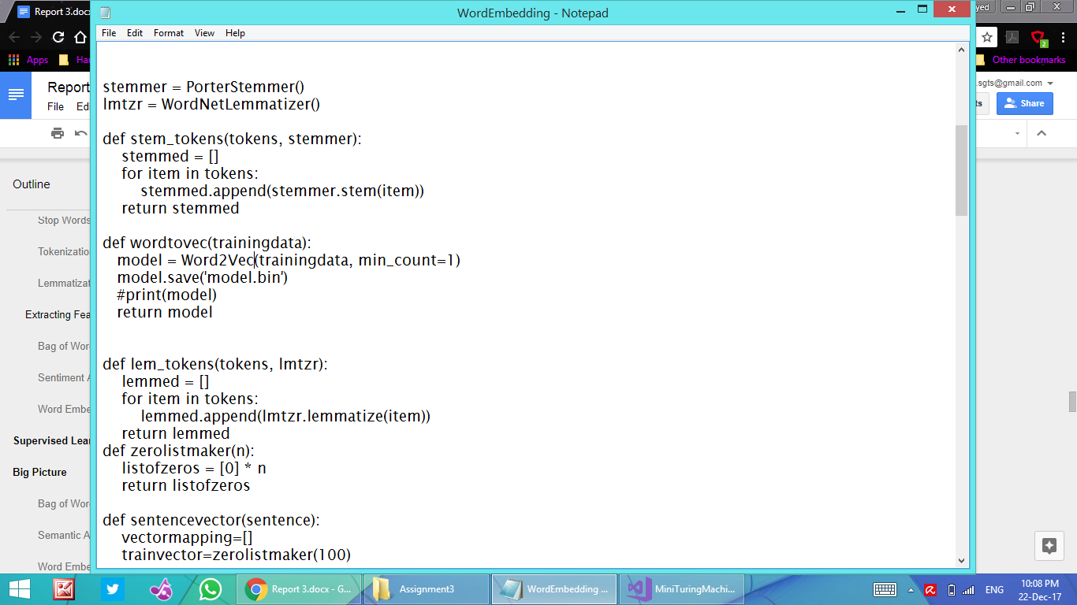

Third, we added all the vectors of the words per tweet and divided this sum by their number. Thus, we acquired a numerical representation of length = 100 for every tweet.

Fourth, we appended all those vectors of all tweets.

Finally, we pass the resulting appended vectors of all tweets to the classifier.

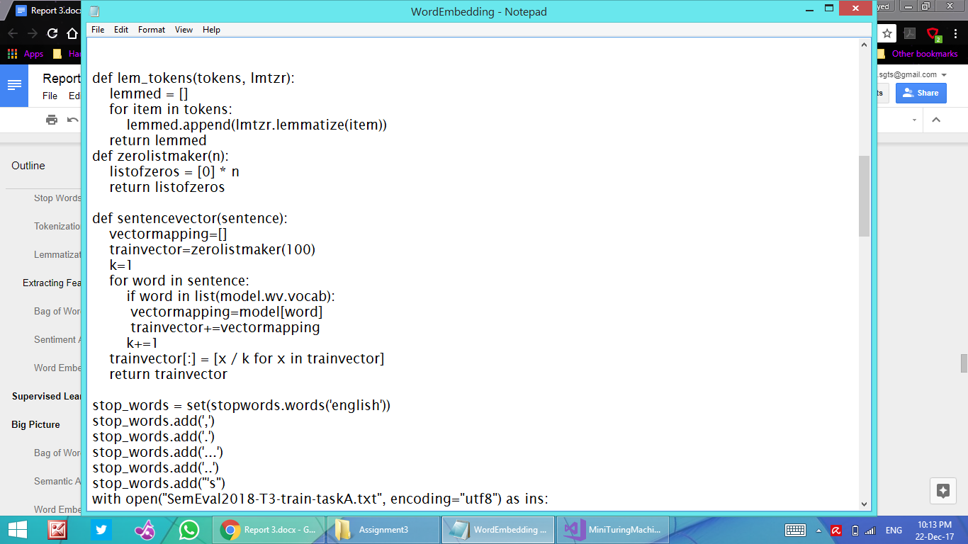

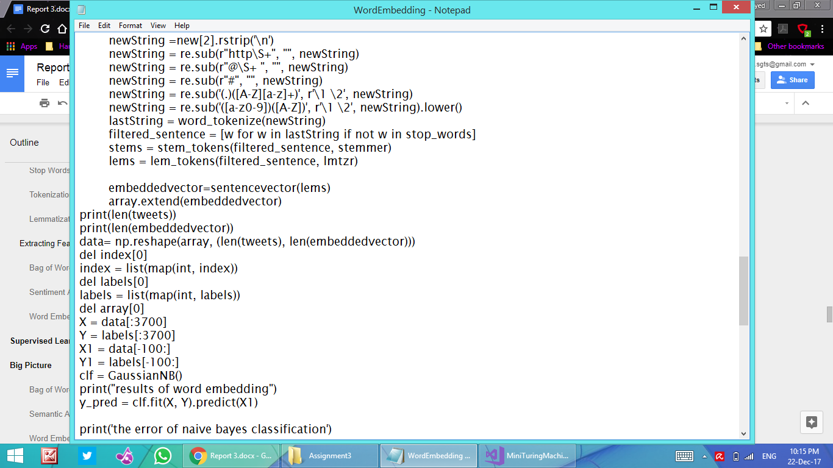

This is the case only with words existing in our dictionary. If the word didn’t exist in the dictionary we made beforehand, a vector of length = 0 is returned.

# Supervised Learning

Using skleran library, four models are used to test the features. We used **two** voting systems. The testing steps are as the following.

1. Each feature is tested on each model. Using a voting system, the best model is picked. The result is 4 possible classifications.
2. Using another voting system, the model with the highest accuracy is picked. If two or more models return the same accuracy, one model is picked randomly from them.

The four models are listed below.

1. **Naive Bayes Classifier**Naive Bayes classifier is a probabilistic classifier that assumes independence between features.
2. **SVM**SVM is a supervised learning algorithm that aims to increase gap between data to divide the data into two category.
3. **Random Forests**Random Forests is an algorithm that generates many decision trees.
4. **K-Nearest Neighbor Classifier**  
   K-Nearest Neighbor Classifier is an algorithm that picks label from k closest data according to a similarity measure. After some tuning, k = 1 generated best results for all the features.

# Big Picture

Below are screenshots of the performance of each feature on **4** models.

### Bag of Words

**Naive Bayes Classifier** results in **best** accuracy.

### Semantic Analysis

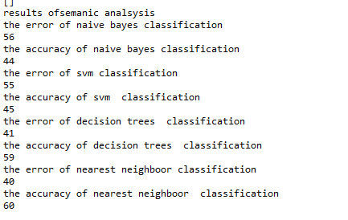

**K-nearest Neighbor Classifier** results in **best** accuracy.

### Word Embedding

**Decision Trees** results in **best** accuracy.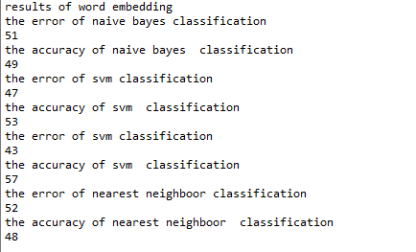

### Overall Results(EXTRA PROCESSING ON ALL FEATURES)

The following evaluations are generated using the evaluation of CodeLab. The input is **100** samples of the prediction of voting system.

Below are the predicted labels from voting System.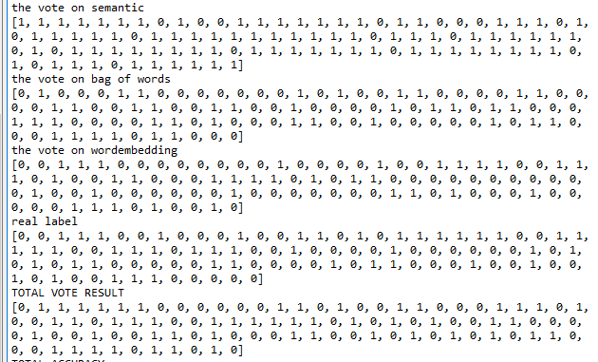

### CodeLab Submissions(BONUS)

We submitted the results of Naive-Bayes Classifier since it was the highest in accuracy.

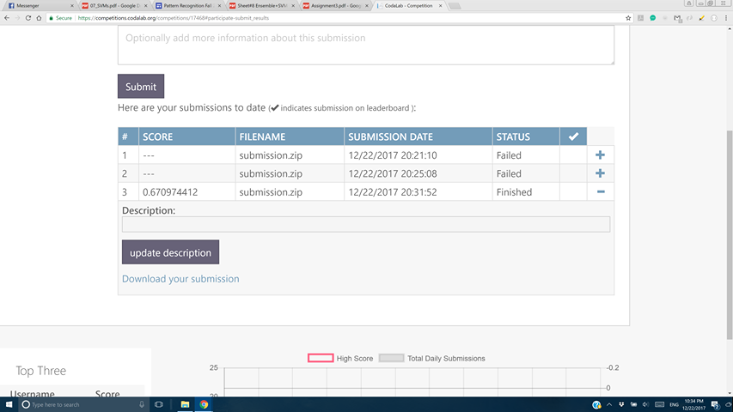

# Python Libraries

* Numpy
* sklearn
* nltk
* re
* gensim